How to bypass Windows Administrator password without knowing the existing password

Article Source:

http://recoverlostpassword.com/article/bypass-windows-administrator-password.html
Windows System: Windows NT/2000/XP/Vista/ 7 and Windows Server 2003/2008

Question: I forgot my Windows Administrator password, how do I bypass Windows Administrator password and regain access to my computer without knowing the existing password

Forgetting Windows Administrator password is really a terrible thing for PC users, even if you can get access with the guess user account. Because only a user account own administrator privilege can change user password, but you are so lucky there are some efficient ways you can try to bypass Windows Administrator password without reinstalling your OS.

WAY 1: Bypass Windows Administrator Password with Password Reset disk

Note: the precondition of bypassing Windows administrator password by the used of a password reset disk is that you must create this disk in advance - before you forgot the password and that disk can only be used to reset the password of the computer it was created on.
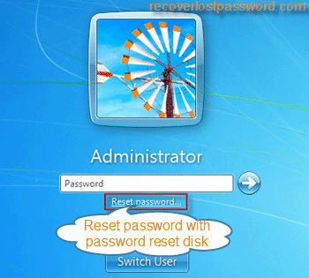
To reset the forgotten Windows admin password (Here take windows 7 as example), follow the steps below:
Step 1: Insert the password reset disk into your locked computer
Step 2: When you input the incorrect password in Windows logon screen, the Reset Password option will pops up, click it.
Step 3: When you click the Reset Password link, a Password Reset Wizard will come up for you to reset the forgotten password.

If you haven’t prepared a password reset disk, it is not a big problem because there are so many 3rd party utility available on the Internet which can help to bypass your forgotten windows password.

WAY 2: Bypass Forgotten Windows Administrator Password with Windows Password Recovery

Here is the most efficient way I have found to bypass a forgotten Windows administrator Password, Windows Password Recovery is a reliable tool designed for bypassing Windows admin Password on PC use own. It allows burning a Windows Password Recovery CD/DVD or Windows Password Recovery USB flash drive to reset forgotten Windows password without knowing the existing password in minutes.
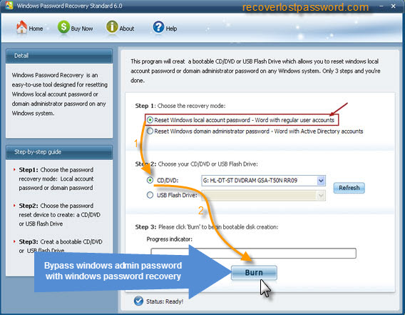
To bypass Windows Administrator Password, follow the steps below:
Step 1: Download Windows Password Recovery and install it
Step 2: Burn a bootable Windows Password Recovery CD/DVD or Windows Password Recovery USB flash drive with the program.
Step 3: Reset Windows Administrator Password to blank with the burned CD/DVD or USB, then bypassing windows password and regain access to your locked computer.

The above two methods all can help to bypass Windows admin Password, and you can choose the perfect solution to fix your windows password problem.

